Noise Contour Mapper
Installation and Setup Guide
Version 1.0.0 · July 2026 · Internal pilot
Noise Contour Mapper converts discrete sound level meter (SLM) measurements into a color-coded noise contour map overlaid on a client floor plan. It supports occupational noise assessments, hearing conservation program planning, identification of high-noise equipment or zones, and communication of noise risk to facility stakeholders.
No API key, account, or internet connection is required. This application runs entirely on your computer. Floor plans, measurements, and exported maps never leave your machine.

1. System Requirements
Operating system | Windows 10 or Windows 11 (64-bit)
Disk space | About 10 MB for the application
Internet | Not required
Prerequisite | Microsoft Edge WebView2 Runtime — already included with Windows 11 and most Windows 10 systems (see Troubleshooting if the app opens as a blank window)

2. Installation
There are two ways to install the application. Both give you the identical tool — pick whichever suits you.

Option A — Portable (no installation)
- Copy the file Noise Contour Mapper.exe to any folder on your computer (for example, your Desktop or Documents folder). It can also be run from a shared drive or USB stick.
- Double-click the file to start the tool. That is all — nothing is installed and no administrator rights are needed.

Option B — Installer (adds a Start menu entry)
- Double-click Noise Contour Mapper Setup.exe.
- Follow the prompts (the defaults are fine). The setup takes a few seconds.
- Start the tool from the Start menu entry Noise Contour Mapper. To remove it later, use Settings → Apps → Installed apps.

First launch — Windows SmartScreen notice
The first time you run the app or the installer, Windows may show a blue “Windows protected your PC” screen. This appears because the file is not code-signed with a commercial certificate (normal for internal tools), not because anything is wrong.
- Click More info.
- Click Run anyway. The notice will not appear again for the same file.

3. Quick Start
The numbered sections down the left side of the window follow the assessment workflow from top to bottom:
- Floor plan — click Load floor plan… and choose a PNG, JPG, or PDF (page 1 of a PDF is used). Click Load demo first if you would like to explore a finished example.
- Scale and coordinates (optional) — click Calibrate, click two points a known distance apart on the plan (such as a dimensioned wall), and enter the real distance. This adds a scale bar. Then click Set origin (0,0)… and click a reference point such as a building corner: from that moment the tool works in real-world coordinates — meters or feet to the right (x) and upward (y) from the origin — instead of image pixels, in the point list, the status bar, and CSV import/export.
- Measurement points — switch to Add points and click each SLM position, typing the measured dBA. Or import a CSV file (label, x, y, dBA) with coordinates in pixels, percent of the plan, or — after calibrating and setting the origin — real meters/feet, exactly as tape-measured on site. Drag markers in Pan mode to fine-tune positions; edit values in the point list.
- Calculation and display — the noise map updates live. Choose inverse distance weighting (IDW), radial basis interpolation, or the source model (below); adjust the color bands (defaults: <80, 80–85, 85–90, 90–95, >95 dBA), opacity, and contour lines.
- Source model + residuals (optional) — instead of interpolating between measurements only, place known equipment as noise sources: click Add source in the toolbar, click the machine's location, and enter its sound level at a reference distance (e.g., 92 dBA at 1 m from a nameplate or close-up reading). Then set the calculation method to Source model + residuals. The tool predicts levels physically (inverse square law, energies added logarithmically) and calibrates the prediction so it matches your SLM readings exactly at each measurement point. Requires a calibrated scale. Sources appear as orange diamonds and can be dragged; their levels are edited in sidebar section 2b. The result is a planning and visualization aid — not a replacement for personal dosimetry or regulatory exposure assessment.
- Export — save the finished map as a PNG for reports, export the points as CSV (with both pixel and real-world coordinate columns when the scale is calibrated), or save the whole assessment as a project file (JSON) to continue later. Each export opens a standard Windows “Save As” dialog.

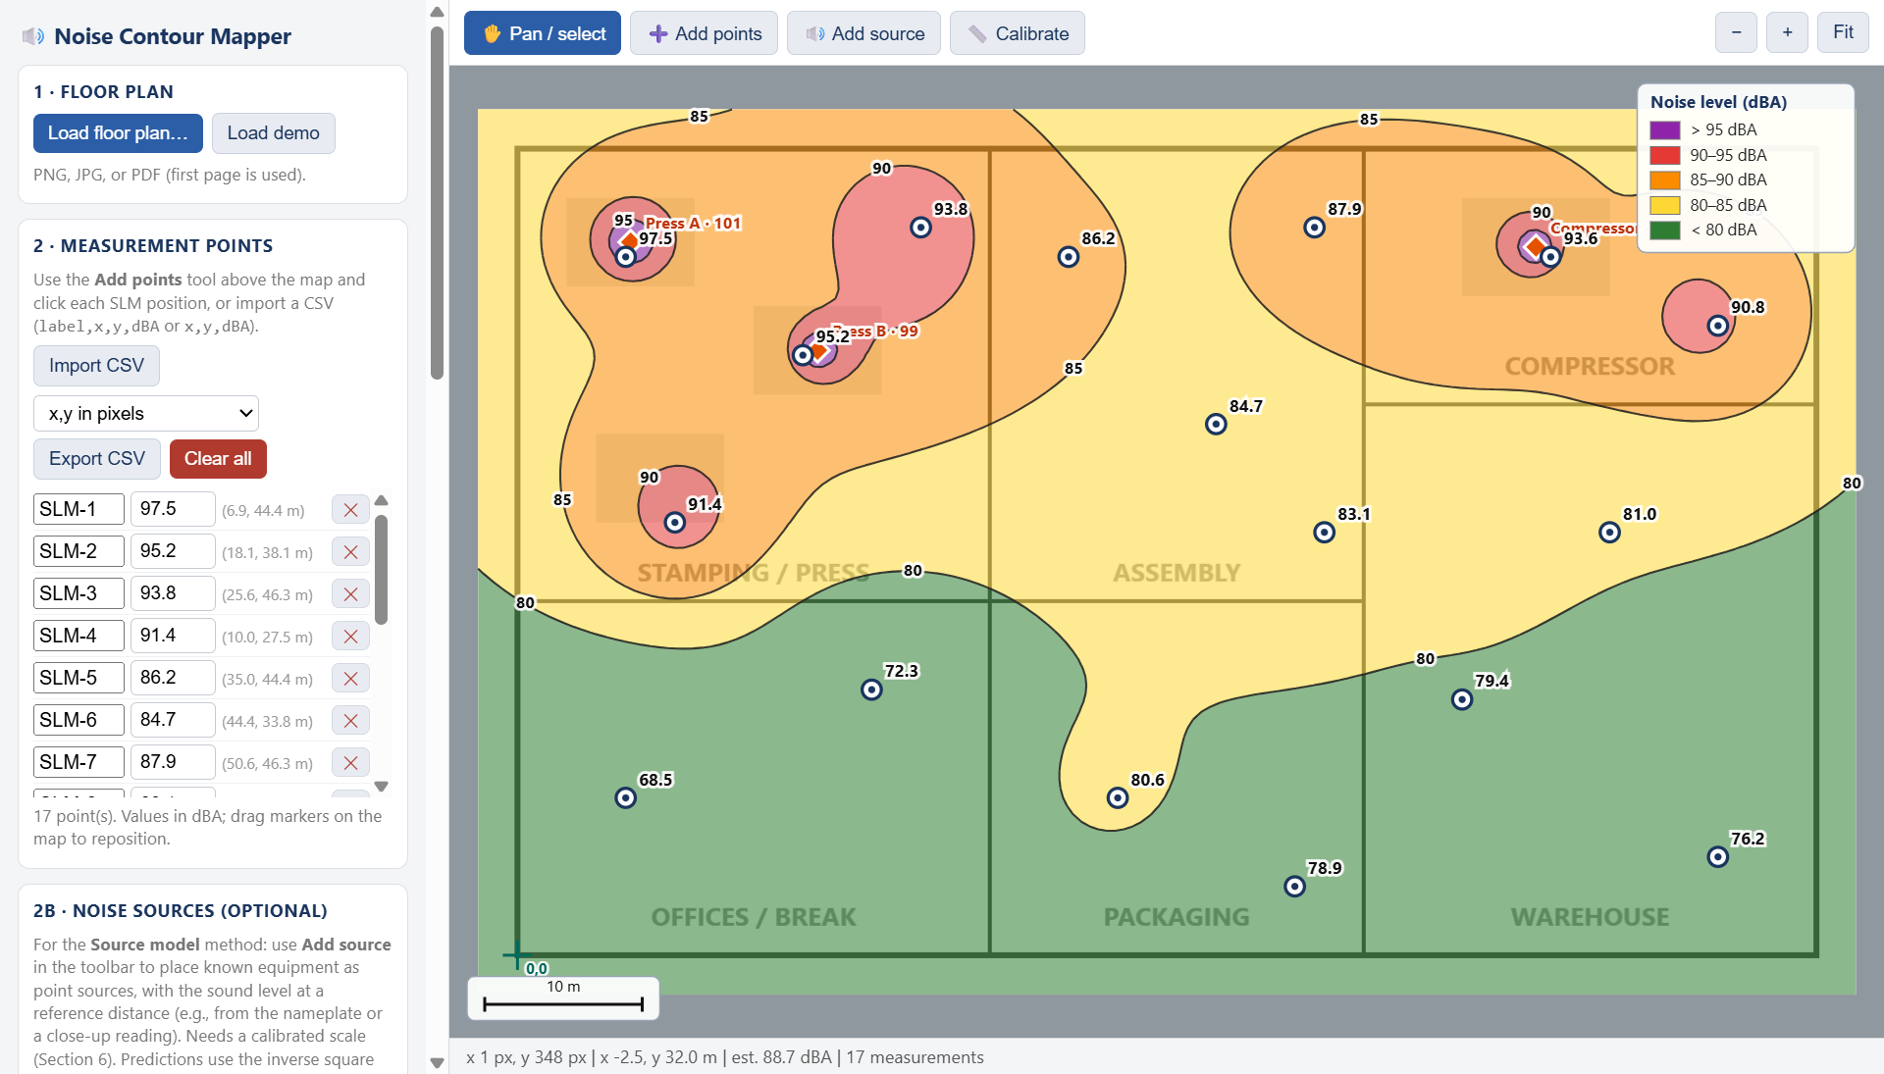
The demo facility using the source model: orange diamonds are noise sources (two presses and a compressor); circles are SLM measurement points; the green crosshair is the coordinate origin.
Good practice: interpolated values are estimates between measurements. Verify critical boundaries (for example, the 85 dBA action level) with additional measurements before making hearing conservation program decisions.

4. How the Map Is Calculated — Methods, Formulas, and Assumptions
Each method produces a continuous estimate of the A-weighted sound level at every location on the plan. The estimate is evaluated on a regular grid (the Grid resolution setting); the color bands come directly from the grid values, and contour lines are traced where the grid crosses each band boundary (for example, 85 dBA). The three methods differ in how the level is estimated between the locations where you actually measured.

4.1 Inverse distance weighting (IDW) — default
The estimate at any location is a weighted average of all measured levels, with closer measurements counting more:
L(x, y) = Σ w_{i} · L_{i} ⁄ Σ w_{i} , w_{i} = 1 ⁄ d_{i}^{p}
L_{i} is the measured level (dBA) at point i; d_{i} is the distance from the location to that point; p is the IDW power setting (default 2).
- Exact at measurement points — the map reproduces every reading at its own location.
- Higher power p makes each reading dominate its own neighborhood; lower p gives a smoother, more averaged map.
- Estimates always stay within the range of the measured values — IDW cannot reveal a hot spot that was not measured.
- Assumption: levels vary smoothly between measurements. No acoustics is modeled.

4.2 Radial basis functions (RBF, multiquadric)
Fits one smooth surface through all measurements, built as a weighted sum of basis functions centered on each measurement point:
L(x, y) = Σ w_{j} · φ(r_{j}) , φ(r) = √(r² + ε²)
r_{j} is the distance to measurement j; ε is a smoothness parameter set automatically to the average spacing between neighboring points. The weights are solved from a linear system so the surface passes exactly through every measurement.
- Produces smoother, more natural gradients than IDW when measurements are sparse.
- Between points the surface may rise above or dip below the measured range — sometimes more realistic, but check the survey edges for overshoot.
- Same core assumption as IDW: pure spatial interpolation, no acoustics.

4.3 Source model with residual correction (hybrid)
The physics-based option (identical math to the companion Python module noise_model.py). It runs in three steps.
Step 1 — Point-source attenuation (inverse square law). Each defined source is treated as a point radiating spherically, losing 6 dB per doubling of distance:
L_{p2} = L_{p1} − 20 · log₁₀( r₂ ⁄ r₁ )
L_{p1} is the source level (dBA) at reference distance r₁ (for example, a close-up reading at 1 m); r₂ is the distance to the location, computed in real units from the scale calibration. Distances are clamped to a minimum of 0.5 m, because the far-field law does not hold immediately next to a source.
Step 2 — Energy addition of sources. Decibels are logarithmic, so contributions are combined by adding acoustic energy — never arithmetically:
L_{total} = 10 · log₁₀( Σ 10^{Li /10} )
Two 90 dBA sources therefore combine to 93 dBA — not 180 dBA.
Step 3 — Residual calibration against measurements. At each SLM point the model error (residual) is computed and spread across the plan with IDW, then added to the prediction:
residual_{i} = measured_{i} − predicted_{i}
Adding a dB offset is a multiplicative correction of acoustic energy. The final map matches your readings exactly at each measurement point while following the inverse-square pattern between them. The residual field absorbs, in aggregate, everything the simple model ignores: reverberation, reflections, barriers and shielding, source directivity, and unmodeled equipment.

4.4 Assumptions and limitations
- Sources are idealized points in a free field. Large machines behave as line or area sources, and reverberant rooms decay more slowly than 6 dB per doubling — indoors the model is a baseline, not an exact solution.
- Steady-state A-weighted levels are assumed; impulsive noise, tonal character, and duty-cycle variation are not modeled.
- Sound paths are not blocked by walls or barriers on the plan — attenuation is distance-only. Residual correction compensates only near the measurements that captured those effects.
- All interpolated or predicted values are estimates. Verify critical boundaries (for example, the 85 dBA action level) with additional measurements.
- The maps support area noise assessment, planning, and stakeholder communication. They are not a substitute for personal noise dosimetry or regulatory exposure determination.

4.5 Choosing a method
Method | Best when | Watch out for
IDW | Plenty of well-distributed measurements; fast survey maps | Bull's-eye patterns around isolated points; cannot show unmeasured hot spots
RBF | Sparse measurements over a smoothly varying area | Overshoot beyond the measured range near survey edges
Source model + residuals | Dominant equipment is known; what-if planning (adding, moving, or quieting machines) | Needs a calibrated scale and reliable source levels; distance-only physics indoors

5. Troubleshooting
Problem | What to do
“Windows protected your PC” appears | Click More info, then Run anyway (see Section 2).
The window opens but is blank/white | The WebView2 Runtime is missing (rare). Download “Evergreen Bootstrapper” from Microsoft’s WebView2 page, run it, then start the app again.
My PDF floor plan shows the wrong page | Only page 1 of a PDF is used. Save the page you need as a separate PDF, or export it as a PNG/JPG image and load that.
Imported CSV points land in the wrong place | Check the units dropdown next to Import CSV (pixels, % of plan, or m/ft). For meters/feet, the scale must be calibrated and the origin set first, and the CSV coordinates must be measured from that same origin point (x right, y up).
Source model shows an empty map | The source model needs a calibrated scale (Section 6 in the sidebar) and at least one noise source placed with the Add source tool. Measurement points are optional but recommended — they calibrate the prediction.
I closed the app and lost my work | Use Save project (Section 7 in the sidebar) while working. Opening the saved project file restores the plan, points, and settings exactly.

Appendix A — Setting Up an Anthropic API Key (for AI-enabled tools)
The Noise Contour Mapper does not use an API key. This appendix applies only to companion tools with AI features — for example, the Robotic Cell Risk Assessment application’s photo/video analysis. Keep it for reference when you install those tools.

A.1 Get a key
- In a web browser, go to https://console.anthropic.com and sign in (or create an account). Company accounts should be set up through your IT/procurement process so billing goes to the right place.
- Open API Keys from the settings menu and click Create Key. Give it a name that identifies you and the tool (for example, “jsmith – risk assessment app”).
- Copy the key immediately — it starts with sk-ant- and is shown only once. If you lose it, delete that key and create a new one.

A.2 Enter the key in the tool
- In the AI-enabled application, open the Settings screen.
- Paste the key into the API key field and click Save. The screen will confirm that a key is stored; you can update or clear it there at any time.
- The key is stored securely in the Windows Credential Manager on your computer — it is not written to a file and does not leave your machine except to authenticate your own requests to Anthropic.

A.3 Key safety rules
- Treat the key like a password: never email it, paste it into chat tools, or share one key between several people.
- Each user should have their own key, so usage can be tracked and a key can be revoked without affecting others.
- If a key may have been exposed, revoke it in the Anthropic console immediately and create a new one.

